Payment Retry to Success

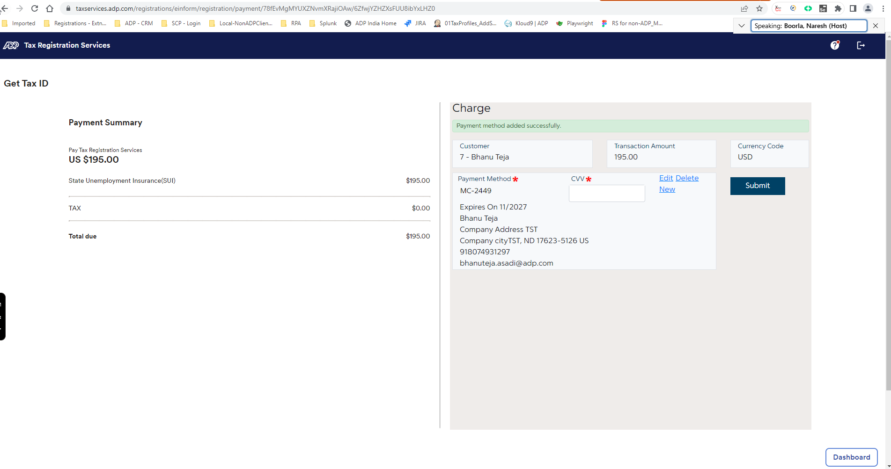

Payment Summary

Retrieve ID

After copied credentials – Retrieve ID

Review Application



